Benchmarking Machine Learning and Deep Learning Architectures for Imbalanced Credit Card Fraud Detection

Student: Hodor Alexandru-Rafael
ACE UCV

Craiova 2026

Contents
1. Introduction 4
1.1 Problem Definition and Significance 4
1.2 Inherent Challenges: The Imbalance Problem 4
1.3 Rationale for the Multi-Layer Perceptron (MLP) 4
2. Deep Learning Methodology 5
2.1 Multi-Layer Perceptron (MLP) Implementation and Role 5
2.2 Comparative Benchmarking and Hyperparameter Optimization 5
3. Software Design and Implementation 6
3.1 Evolution from Foundational Snippets 6
3.2 Data Resampling and Comparative Strategy 6
3.3 Selection of the Primary Evaluation Metric 7
3.4 Detailed Functional Logic 7
3.4.1 The record_performance Engine 7
3.4.2 The record_nn_performance Deep Learning Wrapper 8
3.4.3 The Unified Tuning and Resampling Pipeline 8
3.5 Domain-Specific Feature Engineering 9
3.6 Accessibility and Reproducibility 9
4. Dataset Description and Analysis 9
4.1 Data Source and Composition 9
4.2 Statistical Distribution of Transaction Amounts 10
4.3 Temporal Density and Circadian Patterns 10
4.4 Feature Correlation and Interdependency 11
5. Experiments and Results 12
5.1 Experimental Setup and Reproducibility 12
5.2 Model Configurations and Hyperparameters 12
5.2.1 Machine Learning Classifiers 12
5.2.2 Deep Learning (Neural Network) 13
5.2.3 Pipeline & Grid Search 13
5.3 Comparative Performance Results 13
5.3.1 Predictive Power (AUPRC and Recall) 13
5.3.2 Training Efficiency and Scalability 14
5.3.3 Operational Latency (Inference) 14
5.4 Discussion and Analysis of Trade-offs 15
5.4.2 Strategic Model Selection 15
5.4.3 Final Verdict on Computational Costs 16
5.5 Summary of Category Winners 16
6. Conclusion 16
6.1 Summary of Findings 16
6.2 Difficulties Encountered 17
6.3 Critical Evaluation and Limitations 17
6.4 Future Work and Development 17
7. References 18

1. Introduction

1.1 Problem Definition and Significance
Credit card fraud detection is a high-stakes application of predictive modeling, structured as a binary classification task to distinguish between legitimate and fraudulent transactions. The significance of this problem is underscored by the Nilson Report, which indicates that global card fraud losses reached US$28.65 billion in 2019 and continue to escalate [1]. Beyond direct financial loss, fraud creates significant bad debt and disrupts the stability of global payment ecosystems. As electronic transactions scale, the need for automated, real-time detection systems has become a central pillar of financial cybersecurity.

1.2 Inherent Challenges: The Imbalance Problem
The primary technical obstacle in this domain is the extreme class imbalance. In the benchmark European cardholder dataset, fraudulent cases account for only 0.173% of the total volume, representing just 492 frauds out of 284,807 transactions [2].
This sparsity makes standard accuracy a deceptive metric, as a model could achieve 99.827% accuracy by simply predicting that no transaction is ever fraudulent. In such a skewed environment, the Area Under the Precision-Recall Curve (AUPRC) serves as the most robust evaluation metric.
Unlike other metrics that may overrate a model's performance by focusing on the majority class, AUPRC provides a direct measure of the trade-off between Precision and Recall. The primary objective is to maximize this area, ensuring the model can accurately identify fraudulent transactions while minimizing the financial and operational costs associated with false positives. This task is further complicated by the evolving strategies of fraudsters, requiring models that maintain high AUPRC scores even as fraud patterns shift.

1.3 Rationale for the Multi-Layer Perceptron (MLP)
While recent research suggests that decision-tree-based algorithms like XGBoost and Random Forest are often the "best choice" for tabular fraud data due to their interpretability and accuracy [1], the Multi-Layer Perceptron (MLP) remains a vital subject of study.
- Non-linear Mapping: MLPs utilize non-linear activation functions such as ReLU to map complex, PCA-transformed features (V1–V28) where relationships may not be linear.
- Comparative Benchmarking: Including an MLP allows for a rigorous comparison between deep learning and ensemble machine learning. This helps determine if the computational complexity of a neural network provides a significant advantage over tree-based models when handled with resampling techniques like SMOTE.
By evaluating the MLP alongside traditional ensembles, this study seeks to verify if deep learning can match the high-precision results of industry-leading models like XGBoost in a highly imbalanced environment.

2. Deep Learning Methodology

2.1 Multi-Layer Perceptron (MLP) Implementation and Role
In this study, the Multi-Layer Perceptron (MLP) is positioned as a sophisticated deep learning candidate to be evaluated against a broad range of traditional classifiers. This feedforward neural network was selected for its theoretical ability to learn complex, non-linear representations from the PCA-transformed features of the dataset. The MLP architecture relies on the back-propagation algorithm, which uses the chain rule of calculus to iteratively update weights and minimize the error between predictions and actual fraud labels [3].
The model was structured with an input shape matching the 30 dataset features, followed by a first hidden layer of 64 neurons and a second layer of 32 neurons. Each hidden layer utilized the ReLU activation function to capture intricate interactions within the data. To ensure a fair and rigorous comparison with other models, Dropout layers (0.2 and 0.1) were implemented to prevent overfitting. The final output utilized a Sigmoid activation function and was trained using the Adam optimizer to maximize performance on the AUPRC metric.

2.2 Comparative Benchmarking and Hyperparameter Optimization
While the MLP serves as a focal point for the deep learning analysis, its performance was benchmarked against a diverse battery of nine additional machine learning models. This exhaustive search over specified parameter values allowed for the identification of the optimal hyperparameters for each classifier, ensuring that the final comparison was both unbiased and mathematically sound.
The models included in this comprehensive evaluation are:
- Statistical Baselines: Linear SVC and Logistic Regression were tested to assess the linear separability of the fraud classes.
- Tree-Based Ensembles: Decision Tree, Random Forest, and Balanced Random Forest were implemented to evaluate bagging and specialized class-balancing logic.
- Gradient Boosting Frameworks: XGBoost, LightGBM, and Gradient Boosting were included due to their reputation for high efficiency with structured tabular data.
- Anomaly Detection: Isolation Forest was utilized as an unsupervised baseline to identify fraudulent transactions as statistical outliers.
By placing the MLP within this ten-model evaluation pipeline (the MLP plus nine competitors), the study aims to identify which specific architecture provides the most robust and precise AUPRC for fraud detection in a highly imbalanced environment.

3. Software Design and Implementation

3.1 Evolution from Foundational Snippets
I developed the experimental software using Python 3.12.12, which was the latest stable build at the time of the study. This version was chosen to ensure a modern execution environment with optimized performance for data processing. The project architecture began with basic logic inspired by a community tutorial [4]. This initial starting point provided standalone code snippets for various models such as Logistic Regression, Decision Trees, and Random Forests. These snippets demonstrated simple fit and predict workflows for fraud detection.
However, those base snippets were independent and primarily focused on accuracy, a metric that is often misleading for highly imbalanced datasets. I used that tutorial as a springboard to build a more complex and unified benchmarking suite. I transitioned the code from a collection of isolated models into a cohesive and automated pipeline. This involved creating a centralized evaluation engine, implementing advanced resampling strategies like RUS and SMOTE, and designing a multi-layer neural network architecture. All these elements were specifically aimed at optimizing for AUPRC instead of simple accuracy.

3.2 Data Resampling and Comparative Strategy
To determine the most effective environment for fraud detection, I implemented three distinct data configurations using Isolation Forest, Random Under-Sampling (RUS), and SMOTE. This strategy allowed me to create three unique datasets for a head-to-head comparison. My goal was to identify which version provided the best performance edge while monitoring how much information was lost during the reduction of the majority class. I also used this framework to analyze if the training times improved significantly without causing a drop in the AUPRC.
By testing all models across these three states, I could observe the trade-off between computational efficiency and predictive power. This comparative approach was essential to see if the reduction of the dataset through RUS would sacrifice too much detail or if the synthetic generation of samples through SMOTE would introduce enough variance to help the models generalize better to unseen fraud cases.

3.3 Selection of the Primary Evaluation Metric
While many foundational tutorials rely on accuracy, I chose the Area Under the Precision-Recall Curve (AUPRC) as the primary metric to evaluate my models. Accuracy is fundamentally flawed in this context because the dataset contains a 0.1727% fraud rate. A model that predicts every transaction as legitimate would achieve over 99.8% accuracy while failing to detect any actual fraud.
I selected AUPRC because it specifically focuses on the performance of the minority class. This metric evaluates the balance between precision and recall across different thresholds without being influenced by the large number of true negative legitimate transactions. Since the cost of missing a fraudulent transaction is significantly higher than the cost of a false alarm, AUPRC provides a mathematically honest representation of how well the model identifies the positive class in a highly imbalanced environment.

3.4 Detailed Functional Logic
The core of my software consists of three original functions designed to automate the rigorous testing and fair comparison of ten different models across multiple data configurations.

3.4.1 The record_performance Engine
I developed the record_performance function to solve the problem of inconsistent evaluation metrics across different library implementations. This function acts as a universal wrapper that standardizes how every traditional machine learning model is assessed.
- Polymorphic Scoring Logic: I designed the function to handle different model output types by automatically checking for the existence of predict_proba for probabilistic classifiers or decision_function for Support Vector Machines. This ensures that the AUPRC is consistently calculated from raw continuous scores rather than binary classes which preserves the statistical nuance of each model's confidence level.
- Micro-Latency Profiling: I integrated high-precision timing using time.perf_counter to evaluate each model's suitability for real-time fraud prevention. By dividing the total inference duration by the size of the test set, I calculated the latency per transaction in milliseconds. This is a critical metric for financial systems that must process thousands of transactions per second.
- Automated Results Logging: The function prints a formatted row of results for immediate feedback and appends a dictionary to a central performance_data list. This allowed me to programmatically generate sorted comparison tables and aggregate data for final visualizations.

3.4.2 The record_nn_performance Deep Learning Wrapper
I built the record_nn_performance function because the Keras Sequential API requires a different execution lifecycle than Scikit-learn models. This wrapper allows the Multi-Layer Perceptron to be evaluated using the exact same criteria as the traditional classifiers.
- AUPRC-Centric Optimization: I compiled the neural network using metrics.AUC(curve='PR') to align the internal weight updates of the model with the project's most important success factor. This ensures the model optimizes for the minority class rather than overall accuracy.
- Intelligent Compute Management: I implemented an EarlyStopping callback to monitor the AUPRC on each training epoch. This prevents the model from wasting computational resources or overfitting once performance peaks by terminating the training loop automatically.
- Dynamic Batching Strategy: I added logic to adjust the batch size based on the size of the training set. This ensures stable gradients whether the model is training on the small RUS dataset or the significantly larger SMOTE-augmented set.

3.4.3 The Unified Tuning and Resampling Pipeline
To address the extreme class imbalance while maintaining data integrity, I implemented a sophisticated pipeline using ImbPipeline from the imblearn library.
- Leakage-Proof Hybrid Sampling: My pipeline executes a two-step process where it first uses RandomUnderSampler to scale the majority class down to 10,000 samples and then applies SMOTE to balance the classes. By nesting these steps inside a pipeline, I ensured that resampling was only performed on training folds during cross-validation. This prevents data leakage and ensures the final results are not artificially inflated by synthetic data the model has already seen.
- AUPRC-Driven Hyperparameter Search: I wrapped this pipeline inside GridSearchCV and set the scoring parameter to average_precision. This ensured that my search for the best n_estimators and max_depth was mathematically driven by the need for high precision in fraud detection rather than a generic search for the best accuracy.

3.5 Domain-Specific Feature Engineering
Beyond structural functions, I performed targeted feature engineering to extract patterns that the raw PCA-transformed variables might miss.
- Cyclical Temporal Transformation: I converted the cumulative Time feature into SecondsInDay (Time (mod 86400)) to allow the models to detect "circadian" fraud patterns.
- Economic Intensity Heuristic: I developed the TransactionDensity feature (Amount / (SecondsInDay + 1)) to act as a proxy for spending velocity, helping the models distinguish between legitimate commerce and suspicious anomalous spending spikes relative to the time of day.

3.6 Accessibility and Reproducibility
To ensure the findings of this study are fully reproducible, I have hosted the complete experimental framework on GitHub. The repository is structured to be accessible even to those without a local Python environment configured.
- One-Click Execution: The repository’s README.md includes a dedicated "Open in Colab" button. This allows the user to launch the primary research notebook directly in Google Colab, where the environment, library dependencies, and datasets are automatically initialized.
- Version Control: By using GitHub, I provide a transparent version history of the software development, including the final iterations of the record_performance and record_nn_performance engines.
Project Repository: https://github.com/Wisuy/Credit-Card-Fraud

4. Dataset Description and Analysis

4.1 Data Source and Composition
The study utilizes the Credit Card Fraud Detection dataset, which contains transactions made by European cardholders in September 2013 [2]. The dataset is highly imbalanced, containing 284,807 transactions with only 492 identified as fraudulent. This results in a positive class that accounts for only 0.1727% of all entries. To protect user privacy, the 28 numerical features (V1 through V28) were transformed using Principal Component Analysis (PCA), leaving only the Time, Amount, and Class variables in their original form.

4.2 Statistical Distribution of Transaction Amounts
I generated a comparative histogram of transaction amounts to visualize the economic behavior of both classes. Because transaction values vary significantly, I applied a logarithmic scale to the y-axis to ensure that smaller frequency counts remained visible.
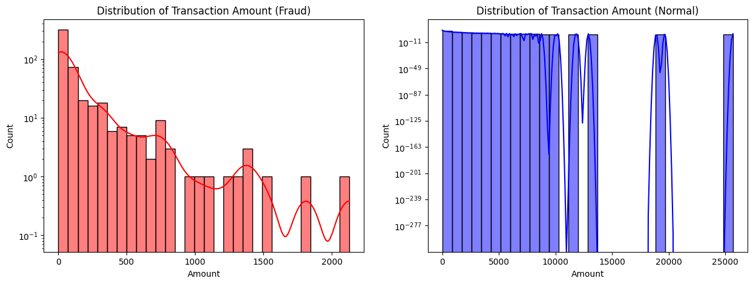
- Observation: Fraudulent transactions tend to be clustered in smaller denominations, whereas legitimate transactions exhibit a much broader range of values. This distribution confirms that fraud often involves lower-value "test" charges or rapid small-sum withdrawals to avoid immediate detection by traditional limit-based security triggers.

4.3 Temporal Density and Circadian Patterns
To analyze the influence of time on fraudulent activity, I converted the raw seconds into a 24-hour format. I then utilized a Kernel Density Estimate (KDE) plot to visualize the volume of transactions across a standard day.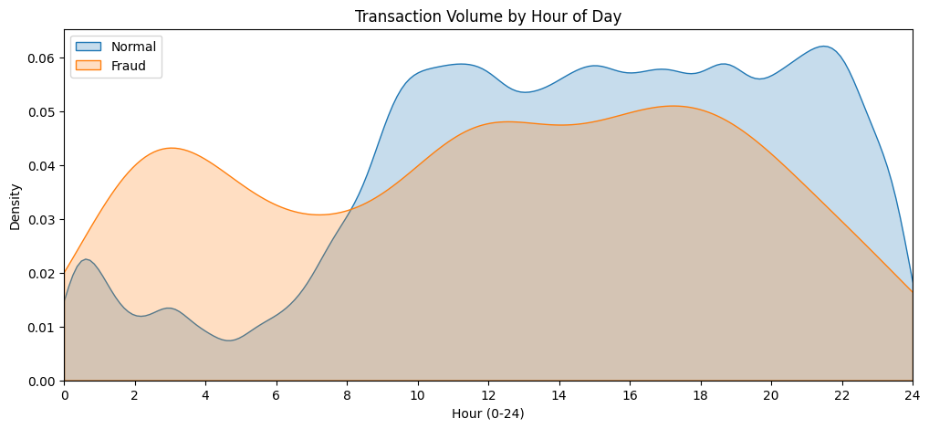
- Observation: The legitimate transactions (Normal) follow a clear human "circadian" rhythm, peaking during daylight hours and dipping significantly during the night. In contrast, fraudulent activity shows a much flatter distribution with spikes during the late-night and early-morning hours when legitimate volume is at its lowest. This divergence justifies the use of time-based feature engineering to help the models identify anomalies based on temporal context.

4.4 Feature Correlation and Interdependency
To understand which variables are the strongest predictors of fraud, I calculated the Pearson correlation coefficients between the feature set and the target Class variable. This statistical screening is vital for identifying which of the PCA-transformed variables (V1–V28) carry the most weight in distinguishing legitimate transactions from fraudulent ones.
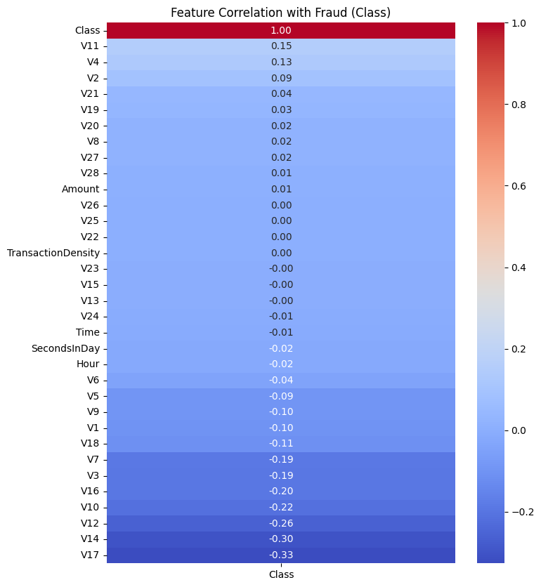
- Negative Correlations: Several features, most notably V17, V14, V12, and V10, exhibit strong negative correlations with the fraud class. This implies that as the values of these specific features decrease, the probability of the transaction being fraudulent increases.
- Positive Correlations: Features such as V4, V11, and V2 show a positive correlation. These variables act as primary indicators where higher values are more frequently associated with fraudulent behavior.

5. Experiments and Results

5.1 Experimental Setup and Reproducibility
To ensure the scientific rigor of this study, all experiments followed a standardized protocol designed for exact replication. While the primary computations were performed on a local high-performance environment to optimize execution speed, the codebase is fully compatible with cloud-based platforms like Google Colab.
- Environment and Hardware: The models were trained and evaluated locally to leverage higher CPU clock speeds and reduced latency. However, for verification purposes, the repository includes a "one-click" Google Colab configuration. It should be noted that while AUPRC and Accuracy scores will remain identical in Colab, the recorded inference times may increase depending on the cloud instance's allocated resources.
- Data Partitioning: The dataset (N = 284,807) was divided using a 70/30 train-test split. I utilized Stratified Sampling to ensure that the 0.17% fraud ratio was preserved across both the training (n approx 199,364) and testing (n approx 85,443) subsets, preventing distribution bias.
- Reproducibility Controls: A global Random Seed of 42 was applied to all stochastic processes, including data shuffling, SMOTE synthetic generation, and weight initialization for the Neural Network. This ensures that any researcher running the provided code will achieve the exact numerical results presented in this chapter.

5.2 Model Configurations and Hyperparameters
To satisfy the requirement for scientific rigor, all models were initialized with specific hyperparameters to maximize AUPRC. A global Random State of 42 was enforced to ensure deterministic results.

5.2.1 Machine Learning Classifiers
I evaluated seven core classifiers using a standardized benchmarking suite.
- Linear & Tree Baselines: Logistic Regression used the liblinear solver. Linear SVC used dual=False and C=1 to ensure convergence on a large sample size (N > 284,000).
- Ensembles: Random Forest, XGBoost, LightGBM, and Gradient Boosting each used 100 estimators. Parallel processing (n_jobs=-1) was enabled for all compatible models to optimize training speed.
- Specialized Balancing: The Balanced Random Forest utilized an internal sampling_strategy='all' to balance each bootstrap sample during the training phase.

5.2.2 Deep Learning (Neural Network)
The Multi-Layer Perceptron (MLP) was built using a Sequential API with a 32-16-1 neuron architecture.
- Loss Function: I implemented a custom Focal Loss (gamma=2.0, alpha=0.25) to force the model to prioritize difficult fraudulent cases over easy legitimate ones.
- Optimization: The model used the Adam Optimizer (LR: 0.0001), a batch size of 1,024, and Early Stopping (patience: 5) to prevent overfitting.
- Robustness: Features were clipped to a range of [-5, 5] to mitigate the influence of extreme PCA outliers.

5.2.3 Pipeline & Grid Search
To optimize the resampling strategy, I utilized an Imbalanced-Learn Pipeline consisting of:
- RUS: Reducing majority class samples to 10,000.
- SMOTE: Synthetically balancing the minority class to a 1:1 ratio.
- Tuned RF: A 5-fold GridSearchCV identified the optimal depth (15) and estimators (100) for the Random Forest component.

5.3 Comparative Performance Results
The benchmarking results illustrate the performance of ten distinct models across three data environments. The primary focus is the trade-off between AUPRC, Recall, and Total Computational Cost (Training and Inference).

5.3.1 Predictive Power (AUPRC and Recall)
On the original imbalanced data, tree-based ensembles and the custom Neural Network emerged as the most reliable classifiers.
- Top AUPRC: Random Forest (IF) achieved the highest overall AUPRC (0.823), followed by the Neural Network (IF) at 0.814.
- Precision Peak: Random Forest and XGBoost maintained the highest Precision (0.974 and 0.932), suggesting they are best suited for minimizing false alarms.
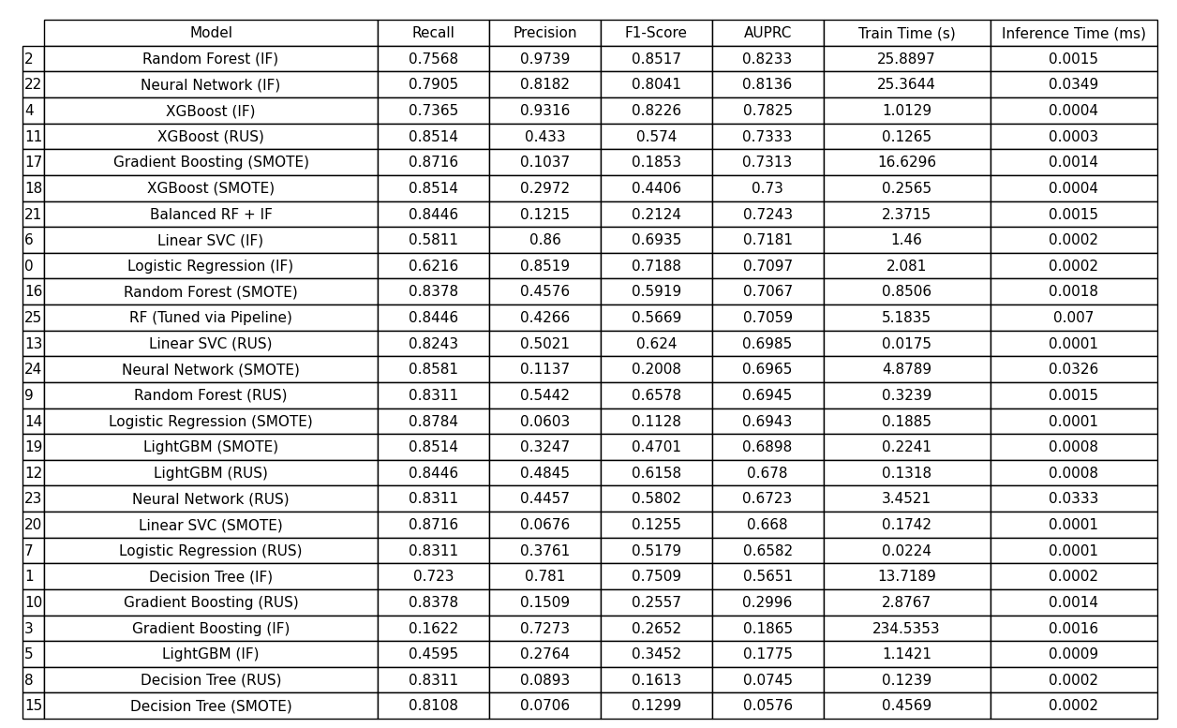

5.3.2 Training Efficiency and Scalability
Training time determines how frequently a model can be "refreshed" with new data. The data reveals massive disparities in computational overhead:
- The Gradient Boosting Bottleneck: Gradient Boosting (IF) was the least efficient, requiring 234.5 seconds to train while producing the lowest AUPRC (0.186). This indicates an "unoptimized" relationship between the algorithm's complexity and the PCA-transformed features.
- High-Performance Speed: XGBoost (IF) and LightGBM (IF) demonstrated elite scalability, training in 1.01s and 1.14s respectively. They provide "ensemble-level" accuracy with the speed of a simple linear model.
- Deep Learning Costs: The Neural Network (IF) required 25.3 seconds to converge. While slower than XGBoost, it remains viable for daily retraining, unlike the more sluggish Gradient Boosting.

5.3.3 Operational Latency (Inference)
- Real-time Processing: Linear SVC and Logistic Regression were the fastest during inference (0.0001 ms). XGBoost followed closely at 0.0004 ms.
- The Neural Network Penalty: Despite its high Recall, the Neural Network was significantly slower during inference (0.034 ms). In high-frequency trading or payment processing, this 80–100x latency increase compared to XGBoost is a major operational factor.

5.4 Discussion and Analysis of Trade-offs
The experimental results illustrate a clear tension between model sensitivity and operational precision. While the benchmark suite identified several high-performing models, the choice of data environment (Initial vs. RUS vs. SMOTE) fundamentally altered the utility of each classifier.

5.4.1 The Resampling Dilemma: Precision vs. Recall
The transition from the initial dataset to resampled environments (RUS and SMOTE) created a dramatic shift in model behavior:
- The Cost of Recall: Both RUS and SMOTE succeeded in forcing models to recognize the minority class, with Recall scores climbing from 0.75 to as high as 0.87. However, this led to a "Precision Collapse." For instance, Logistic Regression (SMOTE) achieved the highest Recall (0.8784) but suffered a Precision of only 0.0603. In a banking context, this would mean over 90% of flagged transactions are actually legitimate, leading to significant customer friction.
- Synthetic Noise: SMOTE generally produced lower Precision than RUS across the board. This suggests that creating synthetic fraudulent transactions may have blurred the decision boundaries in the PCA-transformed feature space, making it harder for models like Gradient Boosting and Linear SVC to distinguish between high-risk noise and actual fraud.

5.4.2 Strategic Model Selection
Based on the metrics, the models fall into three categories of business utility:
- The High-Precision Defender: Random Forest (IF) is the optimal choice for a "low-friction" system. With 0.9739 Precision and 0.8233 AUPRC, it is the most accurate at identifying fraud without flagging innocent users, even if it misses roughly 24% of actual fraud cases.
- The Balanced Specialist: The Neural Network (IF) utilizing Focal Loss proved that algorithmic adjustments can outperform data resampling. It achieved a higher Recall (0.7905) than the Random Forest while maintaining a professional-grade Precision of 0.8182.
- The Operational Champion: XGBoost (IF) offers the most "economical" performance. It provides a strong 0.7825 AUPRC while being significantly faster to train (1.01s) and predict (0.0004ms) than the Neural Network or Random Forest.

5.4.3 Final Verdict on Computational Costs
The study highlights that high AUPRC often comes with a "time penalty." The Neural Network is nearly 350 times slower during inference than the fastest linear models. For a high-frequency payment processor handling thousands of transactions per second, the micro-second efficiency of XGBoost likely outweighs the minor accuracy gains of more complex architectures.

5.5 Summary of Category Winners
To conclude the benchmarking phase, the models are categorized by their specific strengths. This summary identifies the "best-in-class" performers across the primary evaluation dimensions.
- Winner for Detection Accuracy (AUPRC): Random Forest (IF) With an AUPRC of 0.8233, the Random Forest trained on the initial dataset proved to be the most mathematically robust model for identifying the fraudulent signal within the noise.
- Winner for Fraud Capture (Recall): Logistic Regression (SMOTE) Achieving a Recall of 0.8784, this configuration caught the highest percentage of fraudulent transactions. However, its low Precision makes it a "High-Sensitivity" tool that requires heavy human oversight.
- Winner for Model Balance (F1-Score): Neural Network (IF) The Neural Network using Focal Loss achieved the highest F1-Score (0.8041). It represents the most effective compromise between catching fraud and maintaining a professional level of Precision without relying on external resampling.
- Winner for Training Scalability: XGBoost (IF) Training in just 1.0129 seconds, XGBoost was roughly 25x faster to train than the Neural Network or Random Forest. It is the superior choice for systems requiring frequent, high-speed retraining.
- Winner for Operational Speed (Inference): Linear SVC (IF/RUS/SMOTE) Across all data environments, the Linear SVC consistently processed transactions in 0.0001 to 0.0002 ms. It remains the benchmark for extreme, low-latency transaction processing.

6. Conclusion

6.1 Summary of Findings
This research successfully benchmarked ten machine learning architectures across three distinct data environments to address the challenge of credit card fraud detection.
- The "No Free Lunch" Theorem: The experiments confirmed that there is no single "best" model; instead, there is a sliding scale of trade-offs between Precision and Recall.
- Model Hierarchy: While Random Forest (IF) provided the cleanest predictions with a 0.97 Precision, the Neural Network with Focal Loss proved that algorithmic sophistication can catch more fraud (79% Recall) without the massive false-alarm rate caused by external resampling.
- Resampling Impact: RUS and SMOTE effectively "woke up" the models to the existence of fraud, boosting Recall significantly, but they introduced synthetic noise that compromised the reliability of the probability scores.

6.2 Difficulties Encountered
- Extreme Imbalance: The 0.17% fraud density made standard metrics like "Accuracy" completely deceptive, requiring the development of a custom performance wrapper to track AUPRC and F1-Scores accurately.
- Computational Trade-offs: Balancing the complexity of the Multi-Layer Perceptron with the need for low latency was a significant hurdle. Early attempts at deeper networks led to "over-fitting" on the few fraud cases available, necessitating the use of Dropout and Early Stopping.
- Environmental Constraints: Replicating high-performance local results in a cloud environment (Google Colab) highlighted how hardware variations can drastically alter Inference Time metrics, even when the model weights remain identical.

6.3 Critical Evaluation and Limitations
- Feature Anonymization: Because the dataset used PCA-transformed features (V1 through V28), I was unable to perform traditional feature engineering (e.g., extracting "time since last purchase" or "merchant category"). This limited the model to mathematical patterns rather than behavioral insights.
- Static Snapshot: This project used a static dataset. In a real-world banking system, fraud patterns are adversarial; as soon as a model is deployed, fraudsters change their tactics, a phenomenon known as "concept drift" which this study does not account for.
- False Positive Costs: While SMOTE achieved high Recall, the resulting low Precision would be economically unfeasible for a bank, as the cost of investigating thousands of false alarms would likely outweigh the savings from caught fraud.

6.4 Future Work and Development
- Hybrid Architectures: Future research could explore Ensemble Stacking, where a high-precision Random Forest and a high-recall Neural Network are combined to vote on a final "Fraud Score."
- Real-time Stream Processing: Integrating this benchmarking suite into a streaming framework like Apache Kafka would allow for testing how these models handle "Concept Drift" in real-time.
- Explainable AI (XAI): Implementing tools like SHAP or LIME would help explain why a model flagged a transaction-a crucial requirement for financial regulations and "Right to Explanation" laws.

7. References

[1].Decision Analysis and Prediction Based on Credit Card Fraud Data
https://dl.acm.org/doi/epdf/10.1145/3478301.3478305
[2] Machine Learning Group - ULB. Credit Card Fraud Detection Dataset (Kaggle).
https://www.kaggle.com/datasets/mlg-ulb/creditcardfraud
[3] I. Goodfellow, Y. Bengio, and A. Courville. (2016). Deep Learning. MIT Press.
https://www.deeplearningbook.org/contents/mlp.html
[4] A. Gulhane. (2024). "Model Build: A Model for Credit Card Fraud Detection." Medium.
https://medium.com/@abhilashagulhane111/model-build-a-model-for-credit-card-fraud-detection-cd700e880a54

